Writing Half Equations Date: 9/12/2025
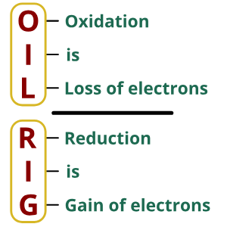
Do Now:
- Define oxidation in terms of electrons.

- Define reduction in terms of electrons.

- True or false? A more reactive metal is more likely to form positive ions.

- Sodium atoms (Na) are oxidised to Na⁺ ions in a reaction. Why is this an oxidation reaction?

- Complete the general word equation to show the product of a reaction between a metal and oxygen.

Metal + oxygen →
Drill:
- State the formula for a chloride ion.
- Spot the spectator ion
H⁺_{(aq)} + Cl⁻_{(aq)} + K⁺ _{(aq)} + OH⁻_{(aq)} → K⁺_{(aq)} + Cl⁻_{(aq)} + H₂O_{(l)}
- What is a displacement reaction?

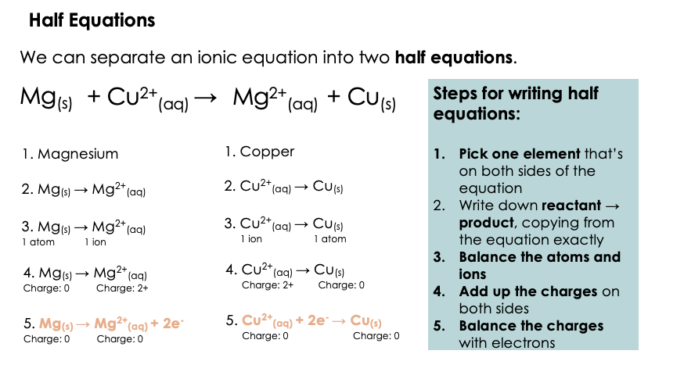

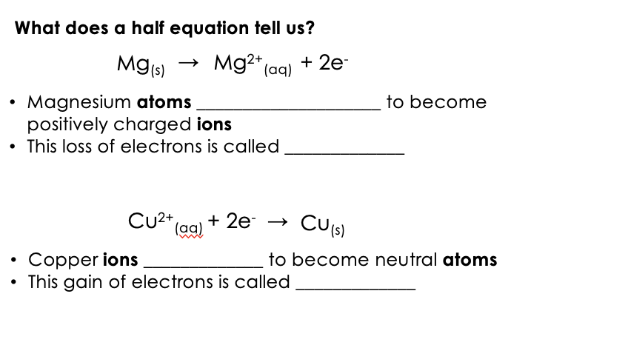

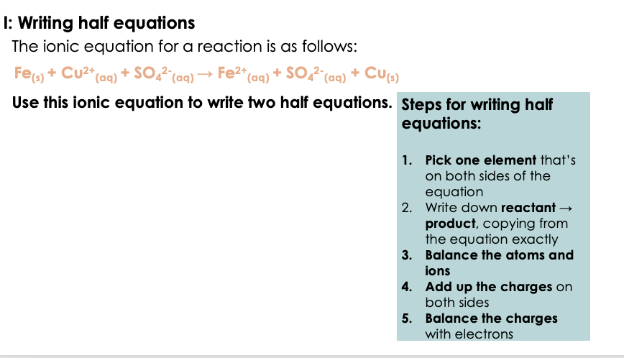

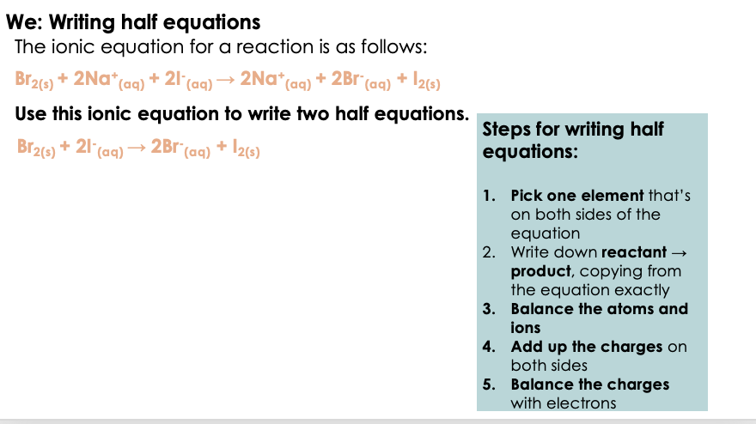

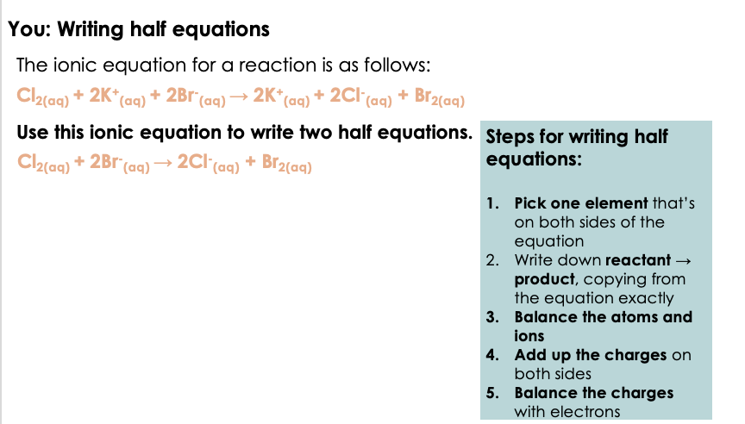
Section A:
- Write out the state symbols below.

(s) - ___________________________ (l) - ___________________________

(aq) - ___________________________ (g) - ___________________________

Fill in the blanks:
Word Bank:
reduced, half-equation, electrons, oxidation, more, replaces, oxidised, reduction
A displacement reaction is when a _____ reactive element ______ a less reactive element from a compound.
A redox reaction is a reaction in which one substance is ___________ and another is ___________.
___________ is when an atom or ion loses ___________.
___________ is when an atom or ion gains ___________.
A ___________ shows only the part of a reaction where an atom or ion loses or gains _______.

- Below shows an ionic equation for a chemical reaction.

Br_{2 (l)} + 2Na⁺_{(aq)} + 2I⁻_{(aq)} → 2Na⁺_{(aq)} + 2Br⁻_{(aq)} + I_{2(s)}
(a) Is this a displacement reaction?
Step 1: Circle the elements that change (from solution to solid, or liquid to solid).
Step 2: Tick the correct box:
☐ Yes, one element is replaced
☐ No, nothing is replaced

- State what is being reduced and what is being oxidised in the reaction.
___________________________________________________________________________
___________________________________________________________________________

- Is this a redox reaction? Explain your answer.
___________________________________________________________________________
___________________________________________________________________________

- Below shows one half equation for this reaction.

Br_{2 (s)} + 2e⁻ → 2Br⁻_{(aq)}

Write the other half equation for this reaction.

___________________________________________________________________________

Section B
Steps for writing half equations:
- Pick one element that’s on both sides of the equation
- Write down reactant → product, copying from the equation exactly
- Balance the atoms and ions
- Add up the charges on both sides
- Balance the charges with electrons

Using the information in the box, write out half equations for the following ionic equations.

- F_{2(g)} + 2I⁻_{(aq)} → 2F⁻_{(aq)} + I_{2(s)}

___________________________________________________________________________
___________________________________________________________________________
___________________________________________________________________________
___________________________________________________________________________
___________________________________________________________________________
___________________________________________________________________________

- Fe_{(s)} + Pb²⁺_{(aq)} → Fe²⁺_{(aq)} + Pb_{(s)}

___________________________________________________________________________
___________________________________________________________________________
___________________________________________________________________________
___________________________________________________________________________
___________________________________________________________________________
___________________________________________________________________________

- Cl⁻_{(aq)} + Ag⁺_{(aq)} → AgCl_{(s)}

___________________________________________________________________________
___________________________________________________________________________
___________________________________________________________________________
___________________________________________________________________________
___________________________________________________________________________
___________________________________________________________________________

Section C
Fluorine, chlorine, and bromine are in Group 7, the halogens.
As you go down the Group 7 elements, reactivity decreases.
Chlorine reacts with a solution of potassium bromide to produce bromine.

- Write the balanced chemical equation for this reaction.

___________________________________________________________________________

- Write the ionic equation for this reaction.

___________________________________________________________________________

- Write two half equations for this reaction.

___________________________________________________________________________

___________________________________________________________________________

- Explain why this is a redox reaction.
___________________________________________________________________________
___________________________________________________________________________

- Using the periodic table, state how many electron shells a chlorine atom and a bromine atom have.
___________________________________________________________________________
___________________________________________________________________________

